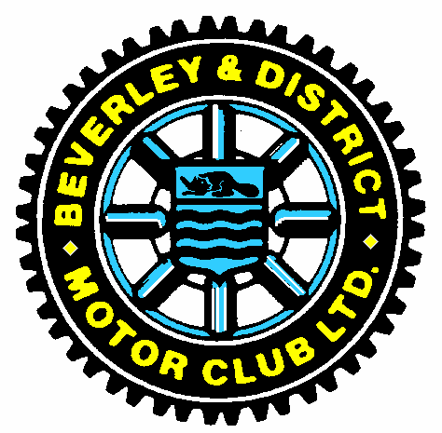
Beverley & District Motor Club
12 Car Rallies

Operating Process 12 Cars Covid 19

- Agree a time with the marshal at each control
- Record the agreed time on your timecard
- Marshal records agreed time at control on their check sheet.
- Route handouts issued at the start in sealed envelopes marked with identifiers (Numbers or Letters).
- Marshal instructs navigator at each control which envelope to open to obtain handout.
- At finish control Navigator shows Marshal which envelopes remain unopen to prove no tampering, Marshal records which envelopes remain unopen on check sheet.
- Marshals to email organiser their check sheet with 24 hours of finish.
- Crews to email organiser their timecard within 24 hours of finish.
- Results sent to Matthew Atkinson by organiser for formal announcement of results via club email or website.

